Impact Evaluation Report 2017
Performance of the South African Poultry Industry
The assessment employs the case study method for two largest and one smallest broiler meat producers in South Africa (Rainbow Chicken Limited, Astral Operations as well as Sovereign Foods) following the tariff support provided by ITAC in 2013.

Overview

The poultry industry is the largest segment of the South African agricultural sector, contributing more than 16 per cent of the sector’s share of gross domestic product. It provides employment, directly and indirectly, for about 138 000 people throughout its value chain and related industries.

However, low-priced poultry imports and rising costs of production have posed major problems for the domestic industry, especially in recent years. Some small and medium sized producers have been forced to shut down. Certain large producers have reduced their workforce and forecast further job losses.

In light of this, the International Trade Administration Commission of South Africa (“ITAC”) increased the general rate of customs duty in September 2013. The aim of the tariff support is to enable the poultry industry to recapture the domestic market, retain and create jobs.

This study gauges performance with respect to progress made on the utilisation of the support against these objectives. The realisation of these policy objectives remains critical in ensuring that ITAC’s trade instruments are efficiently and effectively utilised towards the realisation of the NDP and NGP targets.

Rainbow Chicken Limited (RCL) and Astral Operations are the largest two vertically integrated firms, accounting for almost half of the broiler meat production in South Africa. Sovereign Foods is the smallest vertically integrated producer. Key highlights of the study are presented below. The subsequent

section follows with a detailed discussion of RCL, Astral Operations and Sovereign Foods

- There has been positive growth in the consumption of poultry meat as a source of protein. This presents an opportunity for the poultry industry to produce more so as to bridge the local demand-production gap. Moreover, taking advantage of the rapidly growing exports in Africa to address underutilisation is essential for expanding and sustaining domestic production and employment

- Despite the tariff support, imports are landed on South African market at prices below domestic ex-factory prices (except for Astral). The level of the tariff support could be too low to prevent imports. It should also be noted that the import tariffs imposed in 2013 did not apply to the EU because of the TDCA between South Africa and the EU.

- Input sourcing contributed to differences in performance between RCL, Astral Operations and Sovereign Foods. Broiler feed costs, which constitute about 60-70 per cent of total production costs have been increasing, putting pressure on margins and competitiveness, especially when part of it has to be sourced internationally. The long-term cost competitiveness of the industry depends on low cost supplies of maize and soya.

- One of the reasons for import penetration is that overseas players make their margins on fresh fillet meat and sell the bone-in portions (which are not in high demand in overseas markets) at costs that simply cover the logistics cost of shipping the meat to export destinations.

The Impact of Customs Duty Increase on Poultry in South Africa: The Case of Rainbow Chicken Farms

Introduction

Considering its pivotal role in the economy, particularly employment and food security, and after rigorous assessment and consultation with the relevant stakeholders, ITAC increased the general rate of customs duty in September 2013 on frozen meat and edible offal of chicken such as carcasses with all cuts removed, whole bird, boneless cuts such as chicken breasts, offal such as necks and feet and the bone-in portions such as thighs, wings and drumsticks, classifiable under tariff subheadings 0207.12.20, 0207.12.90, 0207.14.10, 0207.14.20 and 0207.14.90, respectively. The duty on carcasses increased from 27 per cent to 31 per cent ad valorem, while for whole bird it was raised from 27 per cent to 82 per cent, 27 per cent to 30 per cent for offal, 5 per cent to 12 per cent for boneless cuts, and 220c/kg to 37 per cent for other bone-in portions. RCL is one of the beneficiaries of this support. The firm is located in Westville, Durban and is the largest producer in the SACU region.

The aim of the tariff support is to enable Rainbow Farms to retain and create jobs, increase its investment and competitiveness, as well as stimulate production down the value chain.

This study gauges performance with respect to progress made on the utilisation of the tariff support against the above-mentioned policy objectives.

Analytical framework

The effectiveness of a trade instrument provides an indication of the extent to which the stated objectives have been or can be expected to be fulfilled during the defined period. This study is an opportunity to examine the effectiveness of the tariff support provided to the poultry industry, aimed at ensuring greater domestic production, investment, employment, value addition and competitiveness.

Whether or not tariff support to Rainbow Farm has made a positive impact depends on the extent to which the support has resulted in increased domestic investment, employment, value addition and competitiveness after the support was given compared to the period before the support, using firm-level data.

Domestic Production

Rainbow Farms chicken production consist of both “Demand driven” chicken and “Consequential” chicken. The Demand driven chicken, mainly in the format of Nine-Piece Cut (NPC) bone-in portions, represents consistent demand from KFC, Nando’s and Chicken Licken at a stable margin. However, given the specific weight range targeted by the Demand driven customers and bell curve dynamics associated with growing birds, RCL does generate significant “Consequential” volume, mainly in the format of Individually Quick Frozen (IQF) bone-in portions. The Consequential chicken is sold through retail and wholesale channels at significant losses due to an oversupplied market, resulting from excess cheap imports. The essence of the tariff support is on the Consequential chicken to help move volume and to be able to compete with the cheap import pricing.
Evidence shows that the provision of tariff support has seen a gradual shift from the production of more Consequential chicken to that of Demand driven chicken in Rainbow Farms. The share of production of Demand driven chicken to total production increased from 38 per cent in 2012 to 47 per cent in 2015 while the proportion of Consequential chicken declined by 9 per cent over the same period (Figure 1). Rainbow Farms has been reducing bird volumes slaughtered (or Consequential chicken) to match its Demand driven demand, an indication that the tariff support has not been able to limit the significant oversupply of Consequential chicken.

Had it not been for the significant decline in the production of Consequential chicken since 2014, which has not been replaced fully by the increase in the production of Demand driven chicken, Rain Farms would have grown its total production volume by 9 per cent on average (or gained an additional 75 million kg) since the provision of the tariff support (between 2014 and 2015).

However, total production of Rainbow Farms declined by 34.1 million kg (or 9 per cent) in 2014 and 0.3 per cent (or 986 012kg) in 2015. And this is because despite the decline in the production of Consequential chicken, the volume remained 35 per cent and 12 per cent higher than that of Demand driven chicken volume in 2014 and 2015 respectively.

In line with slower growth in production volume, there was a decrease in production utilisation capacity during the period of support than before the support. The Rainbow Farm has accumulated an additional 8 million kg on average per month in capacity utilisation after the support (Figure 2). In particular, the production lines are operating below full capacity.

Figure 1: Total domestic, Demand driven and Consequential chicken

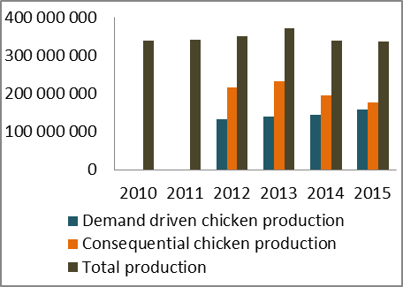

Figure 2: Production capacity utilization

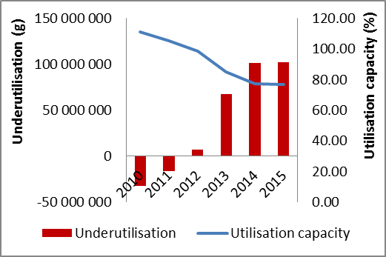

This cast some doubt regarding the sustainability of the local manufacturer following the notable shift from Consequential chicken production to Demand driven chicken production experienced since the provision of the support.

Exports

Rainbow Farms exports its product mainly to Africa and Middle East.

Export volumes still account for a marginal share of total sales in Rainbow Farm. Despite the rand’s weakness, the share of output exported has been on a downward trend, decreasing from 2.5 per cent in 2010-2011t to 1.1 per cent in both 2012-2013 and 2014-2015. On average, export volumes declined by almost 50 per cent from 6.7 million kg prior to support to 3.7 million kg after the support, driven by BLNS countries (figure 3).

However, exports to other African countries have grown rapidly, accounting for over 26 per cent of total company’s exports after support compared to 3 per cent before the support. Taking advantage of the rapidly growing exports to other African countries to address underutilisation in Consequential chicken production) in Rainbow Farms is essential for expanding and sustaining domestic production.

Figure 3: Total exports and sales

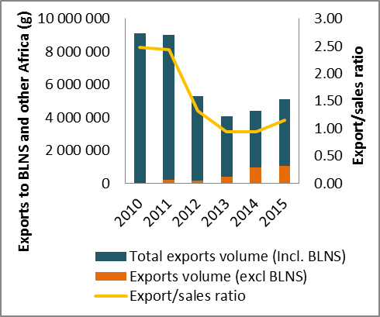

Investment

In analysing investment it is important to not do so in isolation. Comparing the position of the firm before and after the support, Figure 4 shows that real growth in total investment and net profit has declined following a sharp decline in sales.

Consistent with figure 4; domestic sales declined to 4.5 per cent and 2.8 per cent in 2014 and 2015 respectively from 12.2 per cent and 9.4 per cent in the preceding years. This together with a less than desirable increase in profit introduces some elements of uncertainty into the market, discouraging further investment into plant and machinery as well as building.

Figure 4: Total investment, sales and net profit

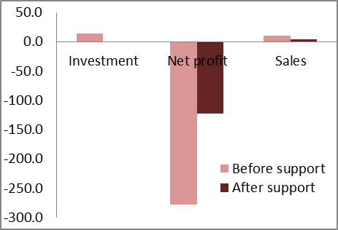

It should however be noted that the decrease in sales and net profit was in Consequential chicken production and not Demand driven category. As a matter of fact, the company has not made a positive contribution margin from Consequential chicken production since 2010, which essentially means that every additional kilogram actually costs the company money to process. And for every chicken slaughtered there is a Consequential amount of offal, and hence the low level of investment by the company could be driven by underutilisation in Consequential production.

Employment

Despite a 4.7 per cent loss of post-support production, Rainbow Farm has created 525 additional direct employment from a total of 7 493 employees in 2012-2013 to 8018 in 2014-2015 (Figure 5), All these new jobs were among the youth between the age 18-35. Had it not been for a loss of 339 jobs among the adults, a total of 864 employment gains would have been made following the provision of the tariff support.

A further examination of the data shows that these new jobs could be driven by output growth in Demand driven chicken category, seeing that more than half of these jobs (289 to be precise) were created in 2015 when the highest growth (10.7 per cent) in Demand driven chicken production was recorded.

Figure 5: Total number of employees

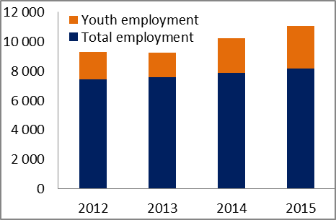

Meanwhile, the 74:26 employment ratio of unskilled versus skilled explains the labour intensive nature of production in Rainbow Farm.

Value addition

Value added by manufacture indicates the approximate value created in the process of production, that is, the contribution of manufacturing establishments to the value of finished manufactured products. Value added is computed by subtracting the sum of the cost of material inputs from the total value of products, which can be expressed as:

Figure 6 indicates that there has been a marginal improvement in total domestic value addition since the imposition of customs duties. The domestic value addition increased from an average of 24.6 per cent in 2012-2013 (before the support) to 29.3 per cent in 2014-2015 (after the support), equivalent to a 4.7 per cent increase.

Figure 6: Domestic value addition

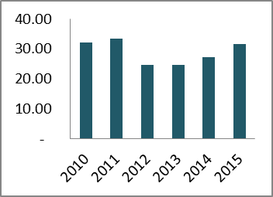

Competitiveness

Total factor productivity growth means that a firm is improving its competitiveness whilst growing its output. Productivity is therefore one of the measures of competitiveness. It demonstrates how efficiently (or inefficiently) a firm is using its resources to produce quality products, and is expressed as the ratio of production output to cost incurred in producing it.

Figure 7 shows that Rainbow Farm’s overall competitiveness deteriorated as witnessed by a decline in total factor productivity before and after the support. However, the rate of decline after the support was moderate compared to before. On average, total factor productivity declined by 4.6 per cent compared to 8.7 per cent before the support. This translates into less output per worker after the support (42 221 kilograms) than before the support (48 220 kilograms).

The decline in total factor productivity may partly be explained by the fact that total production costs (at 0.3 per cent), though lower compared to before the support (particularly material costs, 70 per cent of which are sourced locally), grew faster than production volume which contracted after the provision of the support (figure 8).

Figure 7: Total factor productivity growth

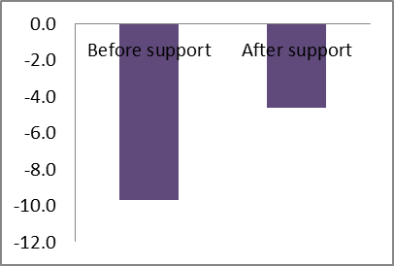

Figure 8: Real growth in costs and output

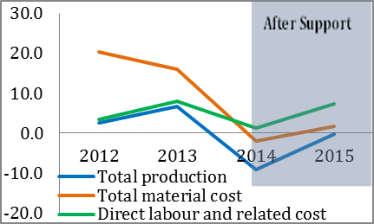

As already pointed out, the preferred and most affordable chicken products consumed in SACU are bone-in portions (HS 0207 14.90) sold as IQF products knows as braai packs. It represents the largest percentage of total production (over 74 per cent) and accounts for the biggest share of imports into SACU. However, South Africa continued to experience huge imports despite the imposition of customs duties.

After decreasing by 10 per cent in 2013 when the customs duty was imposed, total imports of bone-in portions grew at 8.5 per cent (over 12 million kilogram) and 59 per cent (or 93 million kilogram) in 2014 and 2015 respectively. Netherlands, UK, Brazil, Germany and Belgium were the largest importers of this product into South Africa, accounting for over 70 per cent of total imports into the country. However, Brazil, Spain, Belgium and France became the fastest growing importers into the country in 2015, while imports from other EU countries showed a decreasing trend (Figure 9).

Figure 9: Total imports of bone-in portions

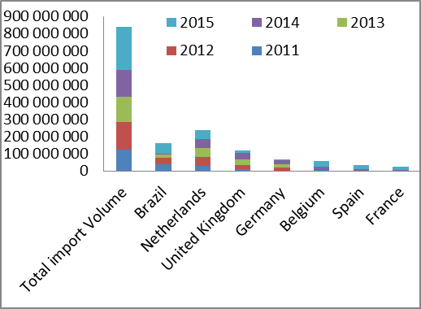

In 2015, imports from Brazil alone grew at over 700 per cent from negative 64 per cent, 45 per cent and 9 per cent in 2014, 2013 and 2012 respectively. The resurgence in imports of the product into the country from Brazil in 2015 could be due to the withdrawal of temporary tariff duties imposed in 2012. Similarly, it is also important to note that in February 2015 ITAC imposed anti-dumping duties against Germany, the United Kingdom and the Netherlands, which could explain why we witnessed negative import growth from these countries in that year.

A further introspection of data shows that on average, imports are landed on South African market at prices below Rainbow’s ex-factory prices for all products (see Figure 10).

Figure 10: Average landed price into SA of bone-in portions, and RCF weighted ex-factory selling prices

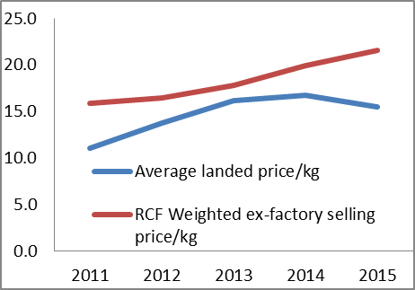

Conclusion

After examining the performance of Rainbow farms in respect of the progress made in the utilisation of the tariff support against set government objectives, the following conclusions are reached:

- Taking advantage of the rapidly growing export markets in African countries to address underutilisation in Rainbow Farms, particularly in Consequential chicken production, is essential for expanding and sustaining domestic production, employment and competitiveness.
- Had it not been for a sharp decline in sales particularly in Consequential chicken, investment could have improved. Investment is a long term decision that requires a high level of certainty in the market which the firm does not seems to be getting at the moment.
- Marginal gains were made in domestic value addition.
- While the imposition of customs duties has reduced the level of imports from Netherlands, UK, and Germany, the flow of import origin has been re-directed to other EU countries, particularly, from Belgium, Spain and France, undermining the benefits that could have been realised from the support.

On average, imports are landed on South African market at prices below Rainbow’s ex-factory prices. In this circumstance, tariff support alone may be inadequate to resolve many of the challenges faced by firms and poultry industry

The Impact of Customs Duty Increase on Poultry in South Africa: The Case of Astral Operations

Introduction

As was the case with Rainbow Farms, Astral Operations also benefitted from ITAC’s increased general rate of customs duty in September 2013 on various chicken products. The firm is located in Gauteng and is a leading poultry manufacturer in the SACU region.

The tariff support is aimed at achieving the objectives of domestic output, investment, employment, equity, value addition and competitiveness as set out in the New Growth Path (NGP) as well as the Trade Policy and Strategic Framework to which the Commission is bound. This study gauges performance with respect to progress made on the utilisation of the tariff provision against the above-mentioned policy objectives.

Whether or not tariff support to Astral Operations has made a positive impact depends on the extent to which the support has resulted in increased domestic investment, employment, value addition and competitiveness after the support was given compared to the period before the support, using firm-level data.

Domestic Production

Total chicken volume slaughtered by Astral Operations has grown since the provision of the tariff support. Figure 1 shows that the firm increased its average annual domestic output from 387 million kilograms before the support to 438 million kilograms after the support (a cumulative growth of more than 4 per cent).

The sharp contraction in output in 2013 was an indication that ITAC’s intervention became necessary. After losing 19.7 million kilograms in 2013, the firm immediately recovered fully, with 3.7 million kilograms gains in output in

2014. This has even increased further to 67.8 million kilograms (or 16.8 per cent) in 2015.

Figure 1: Total domestic manufacture

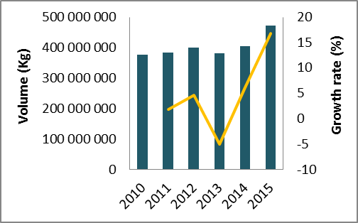

Figure 2: Production capacity utilization

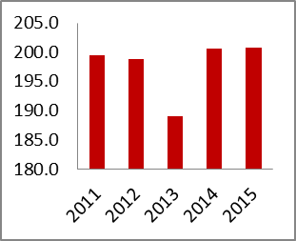

In line with rapid growth in production volume, there was an increase in production utilisation capacity during the period of support than before the support.

Investment

Astral Operation has invested an additional R205 million (or 7.5 per cent of the total investment) since the period of the support. Comparing the position of the firm before and after the support, Figure 3 shows that growth in investment and profit (net) has increased significantly following a sharp increase in sales. In 2015 alone,

Figure 3: Total investment, sales and net profit

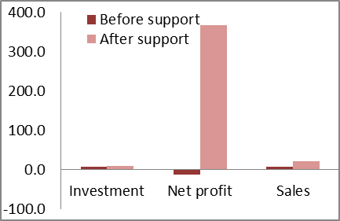

Domestic sales increased on average by 20.7 per cent during 2014-2015 compared to 6.8 per cent and 6.3 per cent in 2011-2012 and/or 2012-2013 respectively. This together with a desirable increase in profit introduces some certainty into the market encouraging further investment after the provision of the tariff support. In 2015 alone, Astral Operations grew its net profit by more than 800 per cent to R599 million from R62 million in 2014.

Employment

The provision of the tariff support has contributed to the employment of 1 570 additional people in Astral Operations from 7 932 in 2010 to 10 524 in 2015 (Figure 4).

Figure 4: Total number of employees

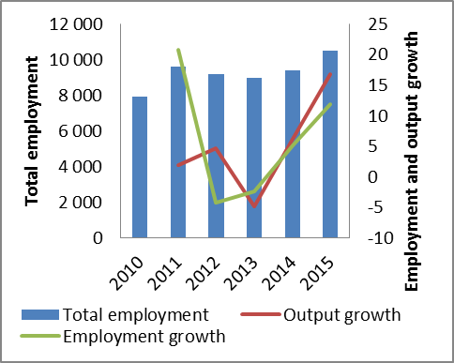

Figure 4 shows that employment almost always responds positively to changes in domestic production after the provision of the tariff support, hence any improvement in the current level of employment would need to sustain the current increase in volume.

Value addition

Value added by manufacture indicates the approximate value created in the process of production, that is, the contribution of manufacturing establishments to the value of finished manufactured products. Value added is computed by subtracting the sum of the cost of material inputs from the total value of products.

Figure 5 indicates that there has been an improvement in total domestic value addition since the imposition of customs duties. The domestic value addition increased from an average of 37 per cent in 2012-2013 (before the support) to 41.4 per cent in 2014-2015 (after the support), equivalent to a 11.9 per cent increase.

Moreover, this firm sourced all its inputs locally, and hence there is no imported value addition.

Figure 5: Domestic value addition

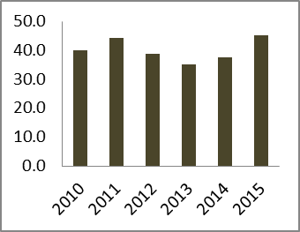

Competitiveness

Total factor productivity growth means that a firm is improving its competitiveness whilst growing its output. Productivity is therefore one of the measures of competitiveness. It demonstrates how efficiently (or inefficiently) a firm is using its resources to produce quality products, and is expressed as the ratio of production output to cost incurred in producing it.

Figure 6 shows that Astral Operations competitiveness deteriorated as witnessed by a decline in total factor productivity before and after the support. However, the rate of decline after the support was moderate compared to before. On average, total factor productivity declined by 2.3 per cent compared to 11.5 per cent before the support. This translates into a marginal increase in output per worker after the support (55 271 kilograms) than before the support (49 207kilograms).

Figure 6: Total factor productivity growth

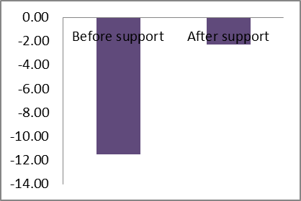

The decline in total factor productivity may partly be explained by the fact that total production costs (driven by direct labour and related costs) grew faster than production volume after the provision of the support (figure 7).

Figure 7: Growth in costs and output
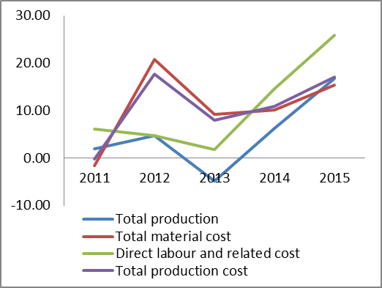

Conclusion

After examining the performance of Astral Operations in respect of the progress made in the utilisation of the tariff support against set government objectives, the following conclusions are reached:

- The firm has made inroads in terms of employment by creating 1 570 additional jobs. A further 5 per cent increase in output each year could see the firm doubling this performance by 2018.
- The support has enabled the firm to recover from a loss of about R200 million in 2013 to record a net profit of more than R60 million in 2014. In 2015 alone, annual profit has increased exponentially by an additional R536.6 million.
- The increase in investment, owing to the tariff support, has provided for additional capacity for future increase in production volume.
- Gains are realised from greater domestic value addition and competitiveness. The support gave the firm a form of protection it needed in the current face of uncompetitive export pricing with the EU and Brazil.

The Impact of Customs Duty Increase on Poultry in South Africa: The Case of Sovereign Foods

Introduction

As was the case with Rainbow Farms and Astral Operations, Sovereign Foods also benefitted from ITAC’s increased general rate of customs duty in September 2013 on various chicken products.. The aim of the tariff support is to enable Sovereign Foods to retain and create jobs, increase its investment and competitiveness, as well as stimulate production down the value chain.

This study gauges performance with respect to progress made on the utilisation of the tariff provision against the above-mentioned policy objectives. The realisation of these policy objectives remains critical in ensuring that ITAC’s trade instruments are efficiently and effectively utilised towards the realisation of the NDP and NGP targets

The effectiveness of a trade instrument provides an indication of the extent to which the stated objectives have been or can be expected to be fulfilled during the defined period. Whether or not tariff support to Sovereign Foods has made a positive impact depends on the extent to which the support has resulted in increased domestic investment, employment, value addition and competitiveness after the support was given compared to the period before the support, using firm-level data.

Domestic Production

The provision of the tariff support has seen an improvement in domestic production following contractions in 2012 and 2013. After losing 6.8 million kilograms in 2012 and 2013, Sovereign Foods immediately recovered 4.5 million kilograms (or 66.6 per cent) between 2014 and 2015, leaving a total of 2.3 million kilograms yet to be recovered.

The firm could have achieved more volumes and recovered fully had the sharp increase in output witnessed in 2014 been sustained in 2015. Nonetheless, had it not been for the tariff support the firm would have lost more in volumes.

Figure 1: Total domestic manufacture

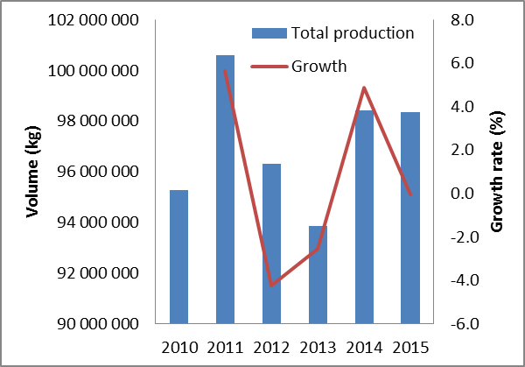

Figure 2: Production capacity utilization

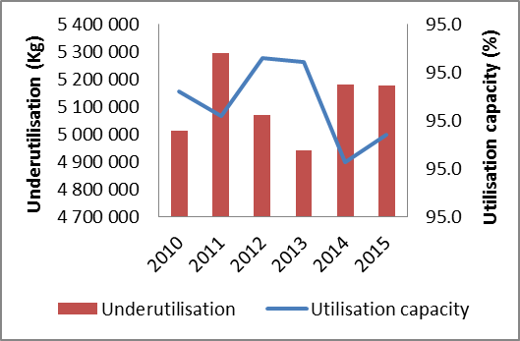

Consistent with Figure 1, The Sovereign Foods has accumulated an additional 173 275 kilograms on average in capacity utilisation after the support (Figure 2). In particular, the production lines are operating below full capacity.

Investment

Astral Operation has invested an additional R205 million (or 7.5 per cent of the total investment) since the period of the support. Comparing the position of the firm before and after the support, Figure 3 shows that growth in investment and profit (net) has increased significantly following a sharp increase in sales.

Figure 3: Total investment, sales and net profit

Domestic sales increased on average by 20.7 per cent during 2014-2015 compared to 6.8 per cent and 6.3 per cent in 2011-2012 and/or 2012-2013 respectively. This together with a desirable increase in profit introduces some certainty into the market encouraging further investment after the provision of the tariff support. In 2015 alone, Astral Operations grew its net profit by more than 800 per cent to R599 million from R62 million in 2014.

Employment

After shelving 191 jobs in 2012 and 2013, the Sovereign Foods managed to retain 133 jobs following the provision of the tariff support in 2014 and 2015 (30 per cent of which are youth under the age 18-35), leaving a total of 58 jobs yet to be recovered. On average, total employment declined from 765 in 2011 to 707 in 2015 (figure 4).

Figure 4: Total number of employees

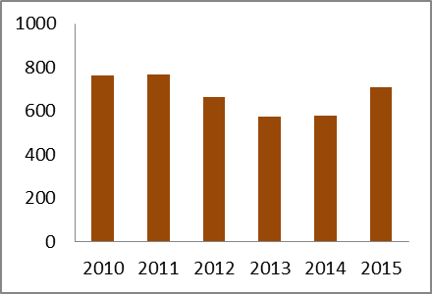

Had the increase in the volume of production recovered in 2014 been sustained, Sovereign Foods could have recovered fully jobs that were shelved before the provision of the tariff support.

Meanwhile, the 5:95 employment ratio of unskilled versus skilled explains the capital intensive nature of production in Sovereign Foods.

Value addition

For a variety of reasons, greater domestic value addition has not been realised since the tariff support was provided. Domestic value addition lowered marginally from 33.20 per cent in 2012-2013 (before the support) to 33 per cent in 2014-2015 (after the support) (figure 5).

Figure 5: Domestic value addition

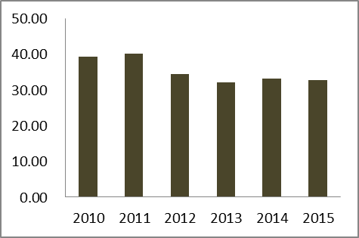

Figure 6: Growth in Domestic and imported input costs

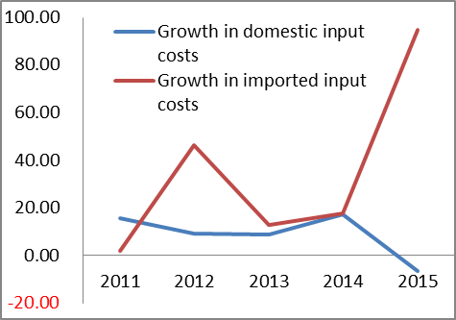

The decline in the domestic value addition was partly due to a sudden increase in the imported input costs, particularly in 2014 and 2015, owing to the recent weaker rand. Over the period of support, the total cost of imported material grew by more than 50 per cent on average compared to 30 per cent before support (figure 6).

Competitiveness

Figure 7 shows that Sovereign Foods competitiveness deteriorated as witnessed by a decline in total factor productivity before and after the support. However, the rate of decline after the support was moderate compared to before. On average, total factor productivity declined by 8.9 per cent compared to 13.3 per cent before the support. This translates into a marginal increase in output per worker after the support (154 543 kilograms) than before the support (154 072 kilograms).

Figure 7: Total factor productivity growth

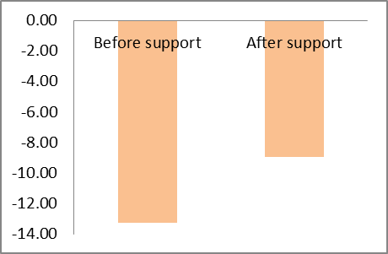

The decline in total factor productivity may partly be explained by the fact that total production costs grew faster than production volume before and after the provision of the tariff support (figure 8).

Figure 8: Growth in costs and output

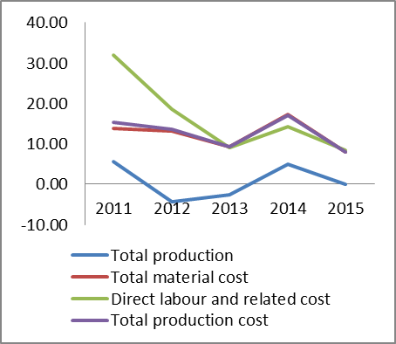

Conclusion

After examining the performance of Sovereign Foods in respect of the progress made in the utilisation of the tariff support against set government objectives, the following conclusions are reached:

- The firm could have achieved more volumes and recovered fully the lost volumes before support had the sharp increase in output witnessed in 2014 been sustained in 2015. Nonetheless, had it not been for the tariff support the firm would have lost more in volumes.
- The increase in sales, together with a desirable growth in profit encouraged further investment after the provision of the tariff support.
- The increase in investment, owing to the tariff support, has provided for additional capacity for future increase in production volume.
- The firm was able to retain 133 jobs after the support was made available. Had the increase in the volume of production recovered in 2014 been sustained, Sovereign Foods could have recovered the remaining 58 of the 191 jobs lost before the support.
- The decline in the domestic value addition was partly due to a sudden increase in the imported input costs, particularly in 2014 and 2015, owing to the recent weaker rand.

Conclusion and policy recommendations

Rainbow, despite the provision of tariff support remains in a precarious state. Astral on the other hand has done very well looking at employments gains, profit increases and increase in production. This could be explained by the fact that while Astral Operations sourced all inputs domestically (and therefore has not suffered significant price increases in input), Rainbow (Sovereign Foods) imports over 30 per cent (10 per cent) on average of its total input.

Drawing on this, one is tempted to say that customs duties in this case do not choose losers or winners. Consequently, what is it that contributed to the difference in performance is input sourcing.

This is true considering that broiler feed costs, which constitute about 60-70 per cent of total production costs have been increasing, putting pressure on margins and competitiveness. Hence, the long-term cost competitiveness of the industry depends on low cost supplies of maize and soya.

It is also important to note that anti-dumping duties on bone-in chicken against USA that were imposed in 2000 have been maintained through sunset reviews in 2006 and 2012. Further anti-dumping duties were also imposed against Germany, the United Kingdom and the Netherlands in 2015.
Of the 5 products, the bone-in cuts represents the largest percentage (over 74 per cent). According to the firm, bone-in cuts are regarded as “lower value” products in developed countries. The white meat is consumed in developed countries while the bone-in cuts (“brown meat”) are exported to SACU in large quantities at prices.
However, one would have expected that tariff protection would, by raising the price of imports, have allowed Rainbow to sell more consequential chicken.
Production utilisation capacity is actual production divided by production capacity or maximum quantity a firm can produce with its machine and labour.
The rand’s weakness has come at an opportune time, though prolonged depreciation will increase the cost of imported inputs and equipment, expanding barriers to entry and expansion.
South Africa is however the biggest chicken consumer per capita on the continent, excluding Mauritius. In due course, Africa is expected to become the home of the global poultry market. As Africa develops, and these opportunities are realised, more and more chicken will be eaten.
Production utilisation capacity is actual production divided by production capacity or maximum quantity a firm can produce with its machine and labour.

