ANNEXURE ‘A’

CUSTOMS TARIFF AMENDMENT

COMMENTS QUESTIONNAIRE FOR

STAKEHOLDERS (Used overcoats, car-coats, raincoats, anoraks, ski-jackets, duffle-coats, mantles, three-quarter coats, greatcoats, hooded caps, trench coats, gabardines, padded waistcoats and parkas (excluding any other clothing articles) classifiable in tariff headings 61.01, 61.02, 62.01, 62.02 and 6309.00.13)

CONFIDENTIAL INFORMATION

Please note that in terms of Section 33 of the International Trade Administration Act, 71 of 2002, and Section 3 of the Amended Tariff Investigations Regulations, if any information is considered to be confidential then a non-confidential version of the information must be submitted, simultaneously with the confidential version. It is imperative to consult the Tariff Investigations Regulations in this regard for the detailed requirements on confidentiality, which apply to all parties and to all correspondence with and submissions to the Commission. Based on these regulations parties must indicate:

- Where confidential information has been omitted and the reasons for the confidentiality of the information omitted; and

- A detailed summary of the confidential information and indexing of numerical data must be submitted to enable interested parties to make meaningful representations on trends and methodology used to determine relevant factors; or

- In cases where information is not susceptible to summary or indexing, reasons must be submitted to this effect.

All correspondence with and submissions to the Commission unless clearly indicated to be confidential will be made available to other interested parties. (Confidential information should be clearly marked by writing “CONFIDENTIAL”) on the cover page of the document and every page that contains confidential information.

If a party considers that any document of another party, on which that party is submitting representations, does not comply with the above rules and that such deficiency affects that party’s ability to make meaningful representations, the details of the deficiency and the reasons why that party’s rights are so affected must be submitted to the Commission in writing forthwith (and at the latest 14 days prior to the date on which that party’s submission is due). Failure to do so timeously will seriously hamper the proper administration of the investigation, and such party will not be able to subsequently claim an inability to make meaningful representations on the basis of the failure of such other party to meet the confidentiality requirements.

VERIFICATION

Please note that in terms of section 8 of the Tariff Investigations Regulations, the Commission retains the right to verify the accuracy of the information supplied to it by any party by conducting verifications.

INFORMATION REQUIRED IN SUPPORT/OBJECTION OF A REVIEW OF REBATE ITEM 460.11/00.00/01.00 (REVIEW)

- COMPANY DETAILS

      - State the full name of the company.

      - State the postal and physical address where operations are carried out.

      - State the web address if available.

      - State the Company’s registration number in terms of the Companies Act.

      - The applicant must provide ITAC with its current SARS electronic access PIN, in order to enable ITAC to verify full tax compliance status.

      - Provide the contact details of the company:

Contact person………………………Tel. …………………..………….
Cell no……………………………………………..
Email………………………………………………..

- DO YOU SUPPORT OR OPPOSE THE REVIEW? IN SUBSTANTIATION, KINDLY INDICATE THE FOLLOWING:

      - States the nature of the business conducted by the company and its entities and kindly provide the business model.

      - Provide a further elaboration on key reasons for the support or objection.

      - If the stakeholder is a local manufacturer of overcoats , provide the following production, sales, employment and investment figures for the period 2018 to date:

Table 1: Local manufacturer of overcoats
 | Year 1 (2018) | Year 2 (2019) | Year 3 (2020) | Current year
Production volumes of textile fabrics (per HS tariff subheading)
Production values of textile fabrics (per HS tariff subheading)
Production capacity (per HS tariff subheading)
Sales volumes (per HS tariff subheading)
Sales values(per HS tariff subheading)
Total employment
*Youth employment
Total investment

NOTE: Provide a technical description of the overcoats concerned.

      - If the stakeholder is a local importer of used overcoats, provide the following figures for the last four years and indicate:

Table 2: Importer of used overcoats
 | Year 1 (2018) | Year 2 (2019) | Year 3 (2020) | Year (Current)
Import volumes of used overcoats (Men’s, Ladies’, Boys and Girls’)
Import values of used overcoats (Men’s, Ladies’, Boys and Girls’)
Sales volume of used overcoats (Men’s, Ladies’, Boys and Girls’)
Sales value of used overcoats (Men’s, Ladies’, Boys and Girls’)
Total employment
*Youth employment
Total investment

      - Kindly provide your current list of customers for used overcoats, supported by verifiable invoices.

      - Kindly provide the volume and value of used overcoats sourced locally within SACU as per Table 3 below:

Table 3: Procurement of used overcoats within SACU
 | Year 1 (2018) | Year 2 (2019) | Year 3 (2020) | Year (Current)
Total volumes of used overcoats sourced locally
Total value of used overcoats sourced locally
      - Cost and price structure

- For manufacturers of used overcoats: provide a cost and price structure as per Table 4 below.

(b) For importers of used overcoats: provide the cost and price structure as Table 5 below.

Note: The format for the cost and price structure is as indicated below:

Table 4: Cost structure of locally manufactured overcoats
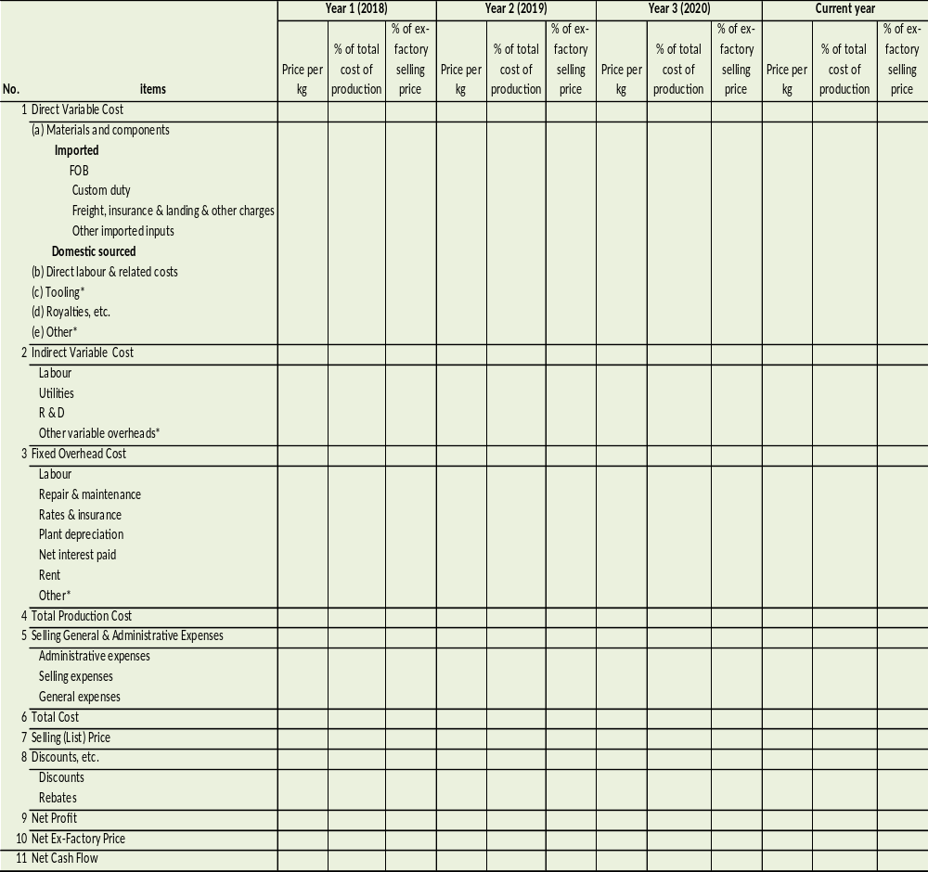
Note: Supply a detailed breakdown of the items in asterisks (*). Cost items such as tooling can be a direct or indirect cost depending on the specific industry. Separate cost analyses must be provided for each of the subject products in this format. This format serves as an indication of the details required by the Commission. This information should be reconcilable to your income statements. Provide a detailed breakdown of the basis of allocation in each case that an allocation has been made.

Table 5: Cost and price structure of imported used overcoats
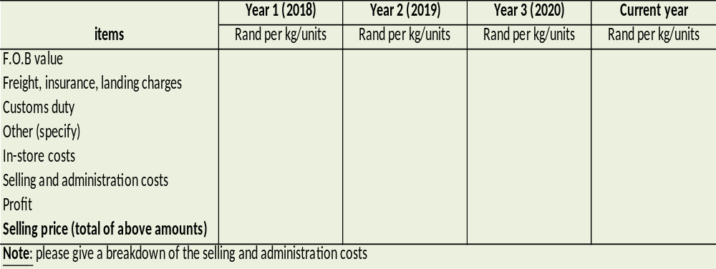

      - How do you support or plan to support the participation in manufacturing and related activities by small businesses, black-owned or black-managed enterprises and Common Customs Area supply chains?

      - Elaborate on the future pricing of the overcoats should the rebate provision be retained.

16. In order to enable ITAC to gauge the performance of beneficiaries against their commitments in terms of employment, provide the following information:

a) A reasonable approximation of the jobs that may be lost should the rebate provision be withdrawn;
b) Similarly, the number of jobs to be created if the rebate provision is retained; and
c) Please substantiate the estimates provide in (a) and (b) above.

17. Any Other Comments:
………………………………………………………………………………………………………………………………………………………………………………………………………………………………………………………

18. Submit the following declaration by the Chief Executive Officer of the company concerned reflected on the company’s letterhead.

I,………..…………………………………………………………………………………(Full name) with identity number,…………………………………….in my capacity as……………... ……………………………………….…of………………………………………………………………. hereby declare that the information furnished in this submission is to the best of my knowledge true and correct.

SIGNATURE:………………...DATE:………………..………………………

I CERTIFY THAT THE DEPONENT HAS ACKNOWLEDGED THAT HE/SHE KNOWS AND UNDERSTANDS THE CONTENTS OF THIS AFFIDAVIT, AND THAT HE/SHE HAS NO OBJECTION TO TAKING THE PRESCRIBED OATH, AND THAT HE/SHE CONSIDERS THIS OATH TO BE BINDING ON HIS/HER CONSCIENCE.

SIGNED and SWORN to before me at ……………………………………

on this ………. Day of …………………………….. Year...........................

COMMISSIONER OF OATHS

